**Add a new Course to that Course Calendar List**

Step 1: Log into Training Scheduler and select the Configuration Tab**.**

Step 2: In the link area located on the right hand side of the screen select the link Add New Course. You should now see a screen that looks like this.

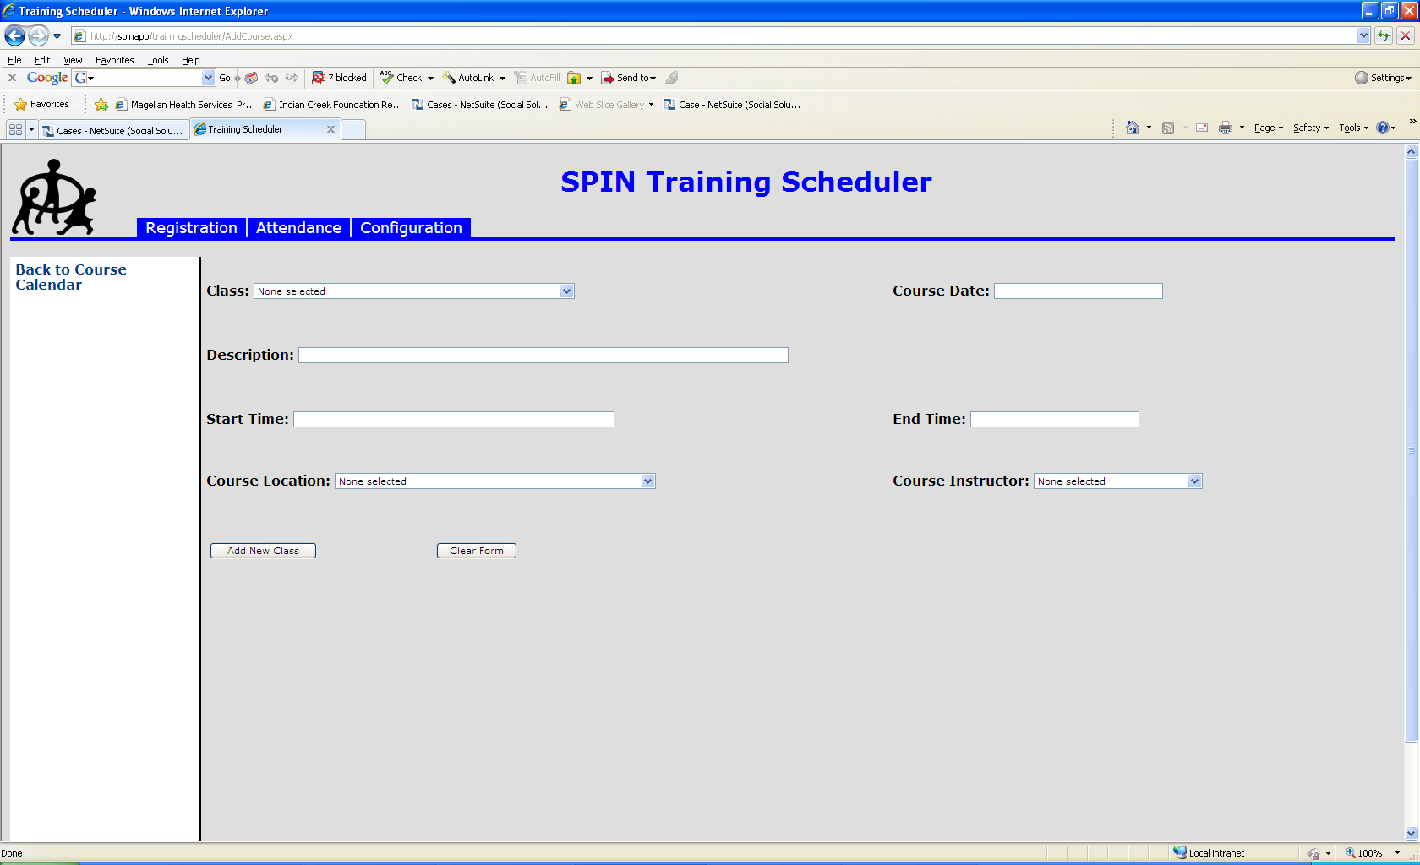

Step 3: With the class selected enter in the date of the new class in the **Course Date** field.

Step 4: After filling out the course date you can enter in a description of the class. If the class is an in-service class then this field is where you would put the title of the class.

Step 5: Fill in the start time using the format of **#:## AM/PM**. After you fill out the start time press the tab button.

Step 6: Once the tab button is pressed the end time will calculate by add the number in parentheses to the start time. If this is not the time you want enter in the correct time in the **End Time** field using the format **#:## AM/PM**.

Step 7: After the end time is filled out you can select a location and instructor for a course using the **Course Location** and **Course Instructor** fields. These fields are not required and can remain blank.

Step 8: Once you are done you can click the **Add New Class** button at the bottom of the screen and you should get a message that looks like this.

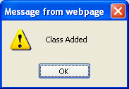

Step 9: If you wish to add another class click the **Clear Form** button and repeat steps 1 thru 8.

Step 10: After you are done adding your courses click the configuration tab to be brought to the course calendar to review what you have done.

